MARKING SCHEME FOR S.5 OPTICS TEST FOR 3RD TERM.

(a)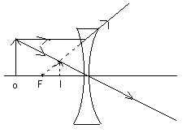

Lens and its axis

Two rays from the object to the image.

a(ii)

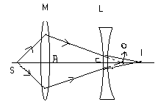

* A converging lens M is arranged with an illuminated object S so as to form a real image on the screen at O.
* The distance, AO, between M and the screen is measured.
* A diverging lens L is then placed between M and O and the screen adjusted to focus the image again at I.
* The distance, CI, is measured.
* Also record the distance between the lenses, AC.
* Calculate the focal length from

1 = 1 + 1

f -(CO) CI

where CO = AO – AC.

(b)

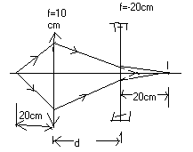

For the converging lens;

U =+12cm, f = +10cm, v = ?

1 = 1 - 1

v 10 20 ⇔ v =20cm.

For the diverging lens; f = -20cm, v = +20cm, u = ?

1 = 1 + 1

-20 20 u

⇔ u = -10cm (virtual object).

But d + 10 = 20

⇔ d = 10

Separation between the lenses = 10cm.

Magnification = m­1 x m2

20 x 20

20 10

= 2.

(c)

|  |  |  |  |  |  |  |
| --- | --- | --- | --- | --- | --- | --- |
| u/cm | 45.0 | 40.0 | 35.0 | 32.5 | 27.5 | 25.0 |
| v/cm | 22.5 | 24.0 | 26.2 | 27.9 | 30.0 | 37.5 |
| (u+v)/cm | 67.5 | 64.0 | 61.2 | 60.4 | 57.5 | 62.5 |
| uv/cm2 | 1012.5 | 960.0 | 917.0 | 906.8 | 825.0 | 937.5 |

Plotting of the points on the graph.

A graph of (uv) against (u + v) gives f as the slope.

The focal length should be (15 ± 0.5) cm.

2 a(i). Principal focus is the point on the principal axis to which all rays originally parallel and close to the principal axis converge after refraction.

(ii). Conjugate points are a pair of points such that if an object is placed at one of them it gives rise to an image at the other.

(b)

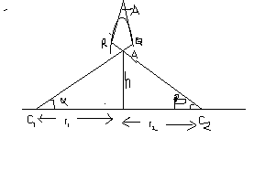

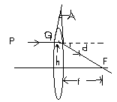

A ray PQ is refracted to F, deviated through d,.

A assuming the angles are small and in radians,

d = h …………. (i)

f

For small angle prism and thin lenses, d = (n - 1)A

∴ h = (n - 1)A………….. (ii)

f

The lines C­2R and C1Q are normal to the surfaces of the lens at R and Q respectively.

From triangle C­2OC1, α + β = A

But α = h and β = h

r1 r2

∴ A = h + h …….. (iii)

r1 r2

Substituting (iii) into (ii), we’ve

1 = (n - 1) 1 + 1

f r1 r2

(b)

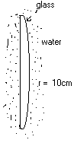

1 = 3 x3 - 1 1 + 1

f 2 4 +10 ∞

⇔ f = +80cm.

For the glass lens;

1 = (n – 1) 1 + 1

f1 24 24

Fo r the liquid lens;

1 = (1.4 - 1) 1 + 1

f2 -24 ∞

* f2 = -60cm.

Let F be the focal length of the combination, then

1 = 1 + 1

40 f1 -60 ⇔ f­1 = 24cm.

∴ 1 = (n - 1) 1 + 1

24 24 24

* n = 1.5

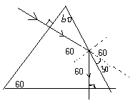

SinC = 1

1.624

∴C = 380

The angle of incidence at the second face is greater than the critical angle. Thus total internal reflection occurs.

The ray hits the third face normally and is transmitted straight through

Deviation = 300 + 300

= 600 .